CINEC Campus • Faculty of Computing
BSc (Hons) Computer Science in Software Engineering (TopUp) — 6CS007 Project and Professionalism

An AI-Assisted Chest X-ray Training Companion
for Student Radiologists Using MedGemma and Retrieval-Augmented Generation

Sharable Diagrams Pack
Use Case Diagram • Activity Diagram • Sequence Diagram

Student: M.W.V.D.M.J. Wijewickrama • Student No: 2642837
Supervisor: Mr. Harindu Mansaka • Module Leader: Mr. Dhishan Dhammearatchi • Reader: Ms. Shanika Ekanayake
Date: 2026-08-30 • Version: v1.0 • Status: For Review / Viva

This pack extracts the three normative design views from Chapter 3 (Methodology) / Chapter 4 (Design) of the Draft Report. All diagrams trace to FR-1 … FR-8 / NFR-1 … NFR-7 (Table 3.8) and to the Clean Architecture ports (Table 3.10).

Item | Detail
Source document | Draft Report.docx — Chapters 3 & 4 (Methodology & Design)
Artefact repo | backend/src/cxt/ (domain/application/infrastructure/interfaces) + frontend/src/ + kaggle_runtime/
Rendering | Matplotlib 3.10.3 → 300 DPI PNG, embedded 1:1 (no re-sampling)
Sharing note | Print-ready A4; also exported as PDF with identical pagination

Contents
1. How to read this pack 3
2. Use Case Diagram 4
2.1 Diagram 4
2.2 Actors & Use Cases (traceability) 4
2.3 Includes / Extends & RBAC notes 5
3. Activity Diagram (Swimlanes) 6
3.1 Diagram 6
3.2 Activity steps & guards 6
3.3 Fork / Join & parallel MedGemma + RAG 7
4. Sequence Diagram 8
4.1 Diagram 8
4.2 Message flow (happy path) 8
4.3 Alternate / error flows 9
5. Traceability matrix (FR/NFR → views) 9
6. Design decisions captured in the views 10
Appendix A. File inventory & how to re-generate 10
How to read this pack

How to read this pack
Each section follows the same pattern: (1) the diagram at full width with a caption that gives its normative Figure number in the Draft Report, (2) a table that explains every symbol, and (3) a traceability note that links the view back to a functional or non-functional requirement so that an examiner can check coverage without opening the code. All three diagrams use the same colour language: blue = system boundary / happy path, amber = MedGemma / <<include>>, green = RAG / persistence, grey = external system. The text in this pack is verbatim from the Draft Report; no requirements or flows have been added or renamed here.
Conventions: dashed lines = <<include>> / <<extend>> (use case), : = lifeline (sequence), rounded rectangles = activities, diamonds = decisions, thick bars = fork/join (activity). JWT = JSON Web Token (HS256, iss/aud), Zod = frontend schema 20–2000 chars, Pydantic = backend re-validation. Lifeline labels match the actual Python/TypeScript module names so that a developer can jump from the diagram to the file.

Use Case Diagram
Normative source: Figure 3.1 (Methodology) — promoted to Figure 4.1 context in Chapter 4. System boundary is the Training Companion System (FastAPI backend + React SPA + Kaggle Runtime tunnel).
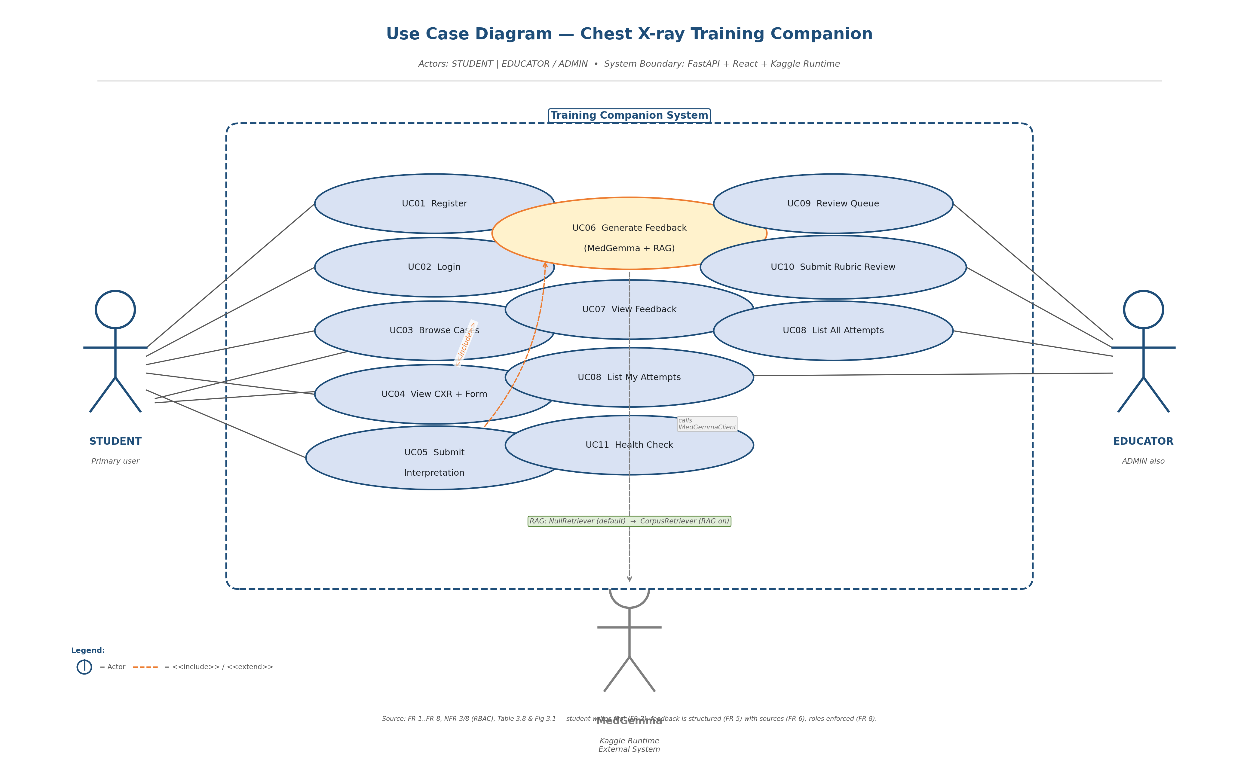
Figure 1 — Use Case Diagram (UC01–UC11). Dashed amber line = UC05 <<include>> UC06; grey dashed = IMedGemmaClient call to external Kaggle Runtime.

Actors & Use Cases (traceability)
Actor / Element | Use Cases / Responsibility | Traces to
STUDENT  (Primary user) | UC01 Register (open) • UC02 Login • UC03 Browse Cases (GET /cases) • UC04 View CXR + write interpretation • UC05 Submit Interpretation (FR-2) • UC07 View Feedback • UC08 List My Attempts • UC11 Health Check (open) | FR-1, FR-2, FR-3/4/5, FR-6, NFR-1
EDUCATOR / ADMIN  (Reviewer) | UC02 Login • UC08 List All Attempts • UC09 Review Queue (GET /reviews/queue) • UC10 Submit Rubric Review (5 criteria × 1–5 + comment) • UC11 Health Check. ADMIN additionally manages invites/seeds. | FR-7, FR-8, NFR-3, NFR-4
MedGemma — Kaggle Runtime  (External system actor) | Provides POST /generate. Called only by KaggleTunnelClient via IMedGemmaClient. No direct user interaction. Swappable with DryRunAnalyzer when KAGGLE_TUNNEL_URL is unset. | Technical Feasibility (Table 3.2), NFR-5, NFR-7
System boundary  Training Companion | Contains UC01–UC11. All use-cases go through FastAPI routes (Table 3.11) and are orchestrated by application use-cases that depend only on ports (ICaseRepository, IMedGemmaClient, IImageAnalyzer, IRetriever, IAttemptRepository, IReviewRepository, IAuthService). | Table 3.10 (Clean Architecture), NFR-7
UC06 Generate Feedback  (<<include>>) | MedGemma analyse + RAG retrieve + OutputParser merge → Feedback entity (likely_finding, key_signs, comparison, missed_clues, learning_point, confidence, sources, raw). Collapsible ‘Show evidence’ panel. | FR-3, FR-4, FR-5, FR-6, NFR-1, NFR-2, NFR-4

Includes / Extends & RBAC notes
• UC05 <<include>> UC06: submitting an interpretation always triggers feedback generation; the student never sees feedback without first submitting (guard enforced in CasePage UI and by POST /attempts requiring a STUDENT role).
• UC06 calls MedGemma: the call is via IMedGemmaClient → KaggleTunnelClient → pyngrok → Flask /generate. The dry-run path returns deterministic JSON so that auth, retrieval and parsing can be tested without a GPU (Technical Feasibility).
• RBAC: STUDENT can POST /attempts; EDUCATOR/ADMIN can GET /reviews/queue and POST /reviews; unauthenticated can POST /auth/register, POST /auth/login, GET /healthz; all other routes require bearer JWT. Implemented in domain Role enum + FastAPI dependency require_role(...) (Table 3.9, FR-8/NFR-3).
• RAG note: NullRetriever (default, returns []) and CorpusRetriever (top-k=3, 500 ch snippets from docs/source_register.csv) share the same IRetriever port; the diagram’s green annotation marks this swap point (NFR-7, FR-4).

Activity Diagram (Swimlanes)
Normative source: Figure 4.4 (Design). Swimlanes make the responsibility split auditable: Student lane = human decisions; Frontend lane = validation/rendering; Backend lane = auth/business logic; Kaggle lane = model inference.
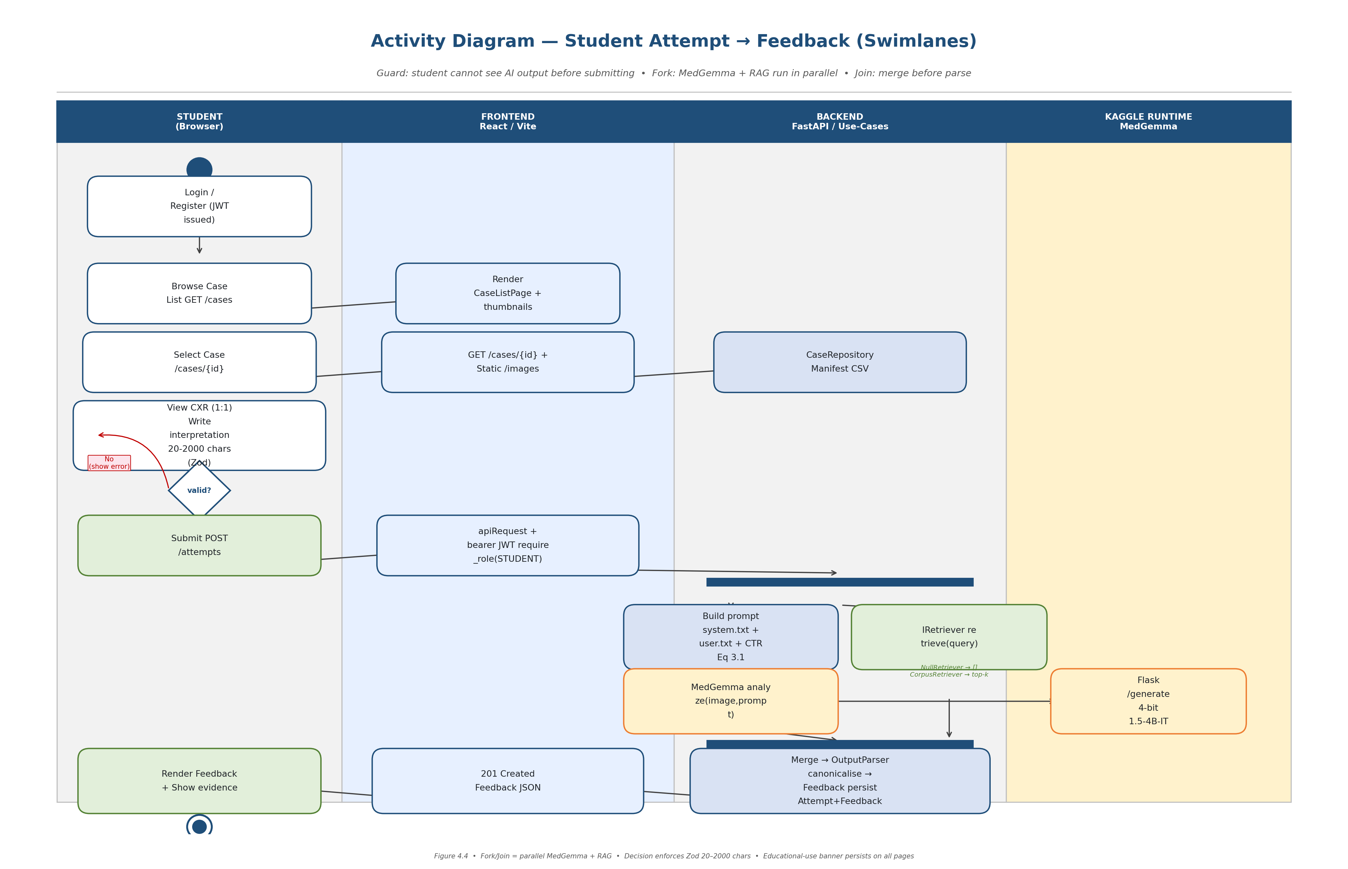
Figure 2 — Activity Diagram (student → feedback). Thick blue bars = fork/join for parallel MedGemma + RAG. Red diamond = Zod validation guard.

Activity steps & guards
Step | Lane | Activity / Guard | Traces to / File
1 | Student | Login / Register → JWT issued (60-min, refresh 7 days) | AUTH.md, backend/src/cxt/infrastructure/auth/
2 | Frontend | Render CaseListPage grid (filter: split/finding/limit) — GET /cases + thumbnails | frontend/src/pages/CaseListPage.tsx, FR-1
3 | Backend | CaseRepository reads manifest CSV → serves /images/* via StaticFiles | backend/src/cxt/infrastructure/data/manifest_repository.py
4 | Student | View CXR (1:1) + write interpretation (Zod 20–2000 chars) — submit is the only transition that reveals feedback | frontend/src/components/AttemptForm.tsx, FR-2
5 | Decision | valid? — No → show Zod error in AttemptForm, loop back; Yes → POST /attempts | NFR-1, NFR-3
6 | Frontend | apiRequest: inject bearer JWT, require_role(STUDENT) pre-check, single-flight 401 refresh | frontend/src/lib/apiRequest.ts
7a | Backend | Build prompt (system.txt + user.txt + RAG block + CTR Eq 3.1 for cardiomegaly branch) | kaggle_runtime/prompts/*.txt, NFR-4
7b | Backend | IRetriever.retrieve(query) — lexical + cosine, k=3, 500 ch cap | backend/src/cxt/infrastructure/retrieval/, FR-4
8 | Backend | Merge → OutputParser → canonicalise FindingLabel → coerce confidence → attach sources → persist Attempt+Feedback | backend/src/cxt/infrastructure/ml/output_parser.py, FR-5/6, NFR-2
9 | Student | Render FeedbackSection: primary finding + confidence %, key signs, comparison, missed clues, learning point + collapsible ‘Show evidence’ | frontend/src/components/FeedbackSection.tsx, NFR-1

Fork / Join & parallel MedGemma + RAG
The fork after POST /attempts models the real implementation: SubmitAttemptUseCase launches IImageAnalyzer.analyze and IRetriever.retrieve concurrently (asyncio.gather in the current code; sequential fallback is identical in behaviour). The join before Merge guarantees that the parser always sees both the raw model JSON and the retrieved passages, even when RAG is off (NullRetriever supplies an empty tuple). This is why the same downstream code serves MedGemma-only and MedGemma+RAG comparisons (AQ3/AQ4).
The persistent educational-use banner (“For educational use only. Not for clinical decision-making…”) is not an activity node; it is a cross-cutting UI invariant shown on every page in the Student and Educator lanes (Legal Feasibility, NFR-1).

Sequence Diagram
Normative source: Figure 4.3 (Design) — SubmitAttempt sequence, happy path + error branches. Lifeline names are the exact module/class names used in the repo so that the diagram is navigable to code.
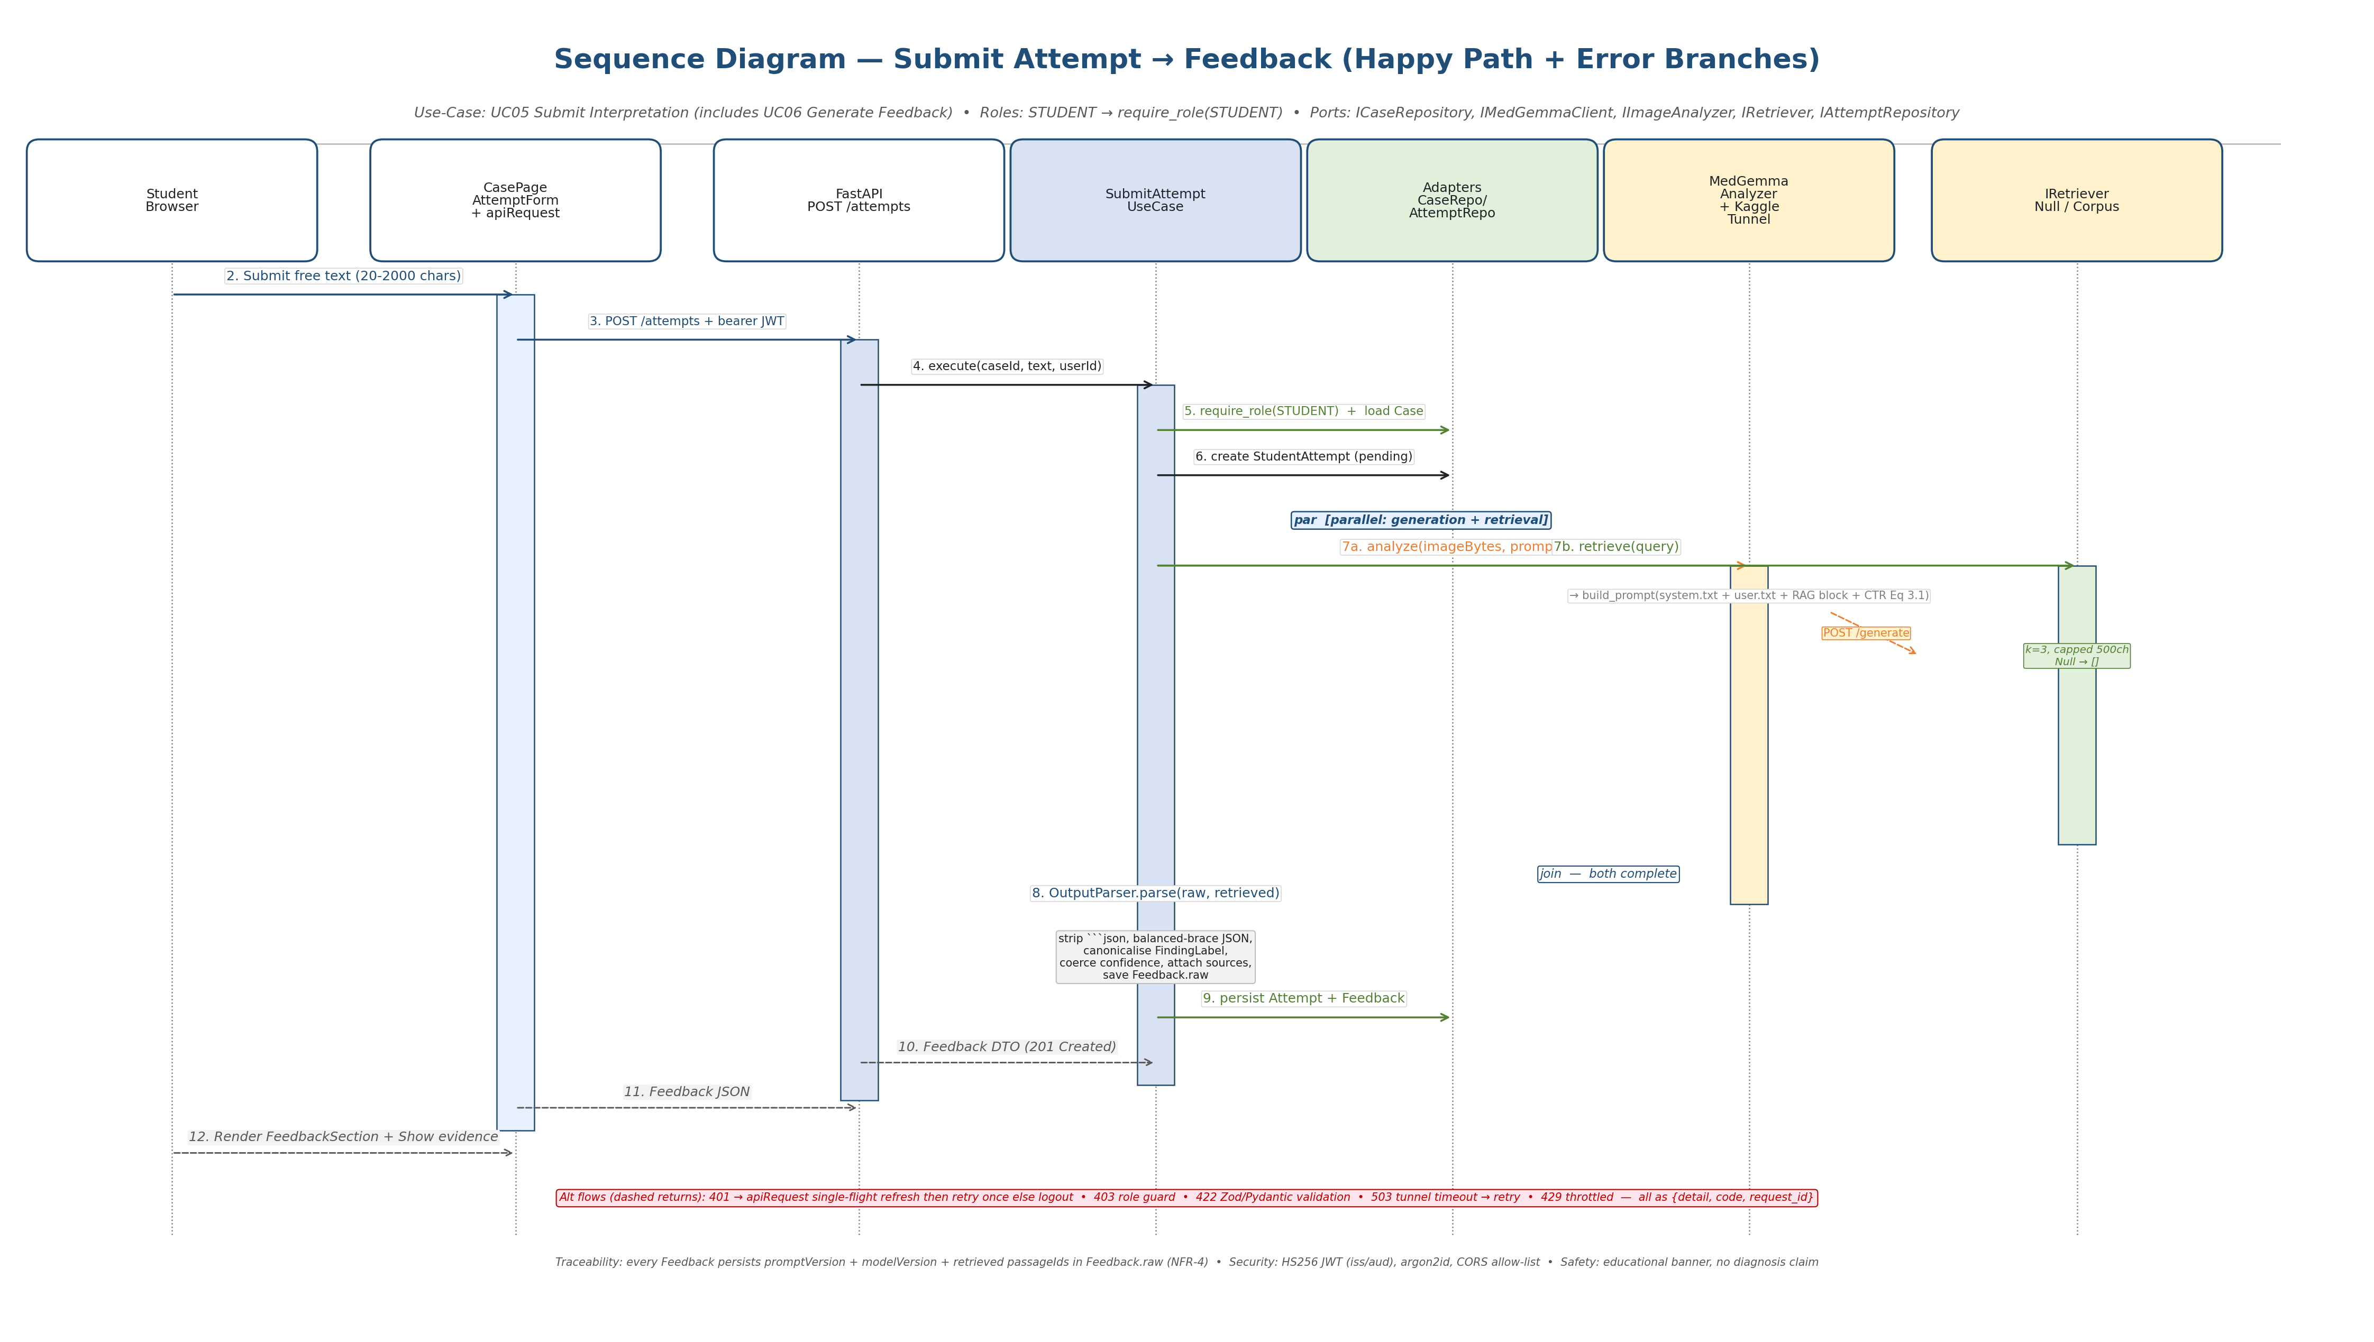
Figure 3 — Sequence Diagram (UC05/UC06). Solid = call, dashed = return. ‘par’ = parallel generation + retrieval. Amber = MedGemma, green = RAG/persist.

Message flow (happy path)
# | From → To | Message / Payload | Notes / File
1 | Student → CasePage | Submit free text (20–2000 chars) | AttemptForm.tsx (react-hook-form + Zod); re-validated by Pydantic on the backend
2 | CasePage → FastAPI | POST /api/v1/attempts {caseId, studentText} + bearer JWT | frontend/src/lib/apiRequest.ts — token-aware, single-flight refresh
3 | FastAPI → UseCase | execute(caseId, text, userId) | backend/src/cxt/application/use_cases/submit_attempt.py
4 | UseCase → Adapters | require_role(STUDENT) + load Case + create StudentAttempt(pending) | domain/entities/, FR-8/NFR-3
5a | UseCase → MedGemmaAnalyzer | analyze(imageBytes, prompt) → build_prompt() → KaggleTunnelClient → POST /generate | backend/src/cxt/infrastructure/ml/medgemma_analyzer.py, kaggle_runtime/medgemma_server.py
5b | UseCase → IRetriever | retrieve(query) → top-k (k=3) | NullRetriever / CorpusRetriever — same port
6 | UseCase → OutputParser | parse(raw, retrieved) → Feedback entity | Strips ```json, balanced-brace JSON, FindingLabel alias map, confidence [0,1], 500 ch cap (NFR-1/2)
7 | UseCase → AttemptRepository | persist Attempt + Feedback (incl. Feedback.raw: promptVersion, modelVersion, passageIds) | NFR-4 traceability
8 | FastAPI → Browser | 201 Created + Feedback DTO | Global {detail, code, request_id} envelope on errors
9 | Browser → Student | Render FeedbackSection + ‘Show evidence’ panel | FR-5, FR-6, NFR-1

Alternate / error flows
Condition | Response | How the diagram shows it
401 Missing/expired JWT | apiRequest refreshes once (single-flight) then retries; second 401 → logout + redirect to /login | Dashed return labelled ‘401’ in the alt note below the 3→4 arrow; not a separate lifeline to keep the happy path readable
403 Role guard | POST /attempts with non-STUDENT role → 403 {detail: ‘forbidden’} | require_role(STUDENT) activation bar returns 403 before step 4
422 Validation | Text <20 or >2000 chars, or unknown caseId → 422 Validation Error | Decision diamond in the Activity view; sequence shows Pydantic re-validation inside UseCase
503 Tunnel timeout | Kaggle pyngrok session expired or model cold-start → 503 ‘model unavailable, retry’ | Dashed return from MedGemmaAnalyzer to UseCase; caller shows retry CTA
429 Throttled | Kaggle / API rate-limit → 429 Retry-After | Same 503 path; frontend surfaces a countdown

Every message carries a request_id (middleware in backend/src/cxt/interfaces/api/middleware/request_id.py) that is logged on the backend and returned in the error envelope so that a failed Attempt can be correlated with its Feedback.raw record — the same ID is shown in the sequence’s alt note at the bottom.

Traceability matrix (FR/NFR → views)
Requirement | Use-Case view | Activity view | Sequence view | Code / Table
FR-1 Display CXR | UC03, UC04 | Steps 2–3 (Browse/Select + CaseRepository) | Messages 3–4 (GET /cases, /cases/{id}) | FR-1, Table 3.11, manifest_repository.py
FR-2 Record own interpretation before AI | UC04, UC05 (guard) | Step 4 + Decision valid? | Message 1 (Zod) + guard not to expose feedback early | AttemptForm.tsx, NFR-1
FR-3 MedGemma analyse | UC06 (amber) | Steps 7a (Build prompt + MedGemma) | Message 5a | medgemma_analyzer.py, NFR-5
FR-4 RAG retrieve | RAG annotation | Step 7b (IRetriever) | Message 5b (par) | IRetriever, NFR-7
FR-5 Generate feedback note | UC06/UC07 | Step 8 (Merge→Parser→Feedback) | Message 6 (OutputParser) | feedback.py, output_parser.py
FR-6 Display sources | UC07 ‘Show evidence’ | Step 9 (FeedbackSection) | Message 9 (sources tuple) | FeedbackSection.tsx, NFR-2
FR-7 Educator review | UC09, UC10 | — (Educator lane, same pattern) | — (ListReviewQueueUseCase / ReviewAttemptUseCase) | FR-7, review_queue, RBAC
FR-8 RBAC | Actors + require_role | Lane headers + guard | Message 4 (require_role) | user.py, dependencies.py
NFR-1 Clarity at student level | UC07 labels | 500 ch caps, plain defaults | Message 6 canonicalisation | output_parser.py (NFR-1)
NFR-4 Traceability | Feedback.raw note | — | Message 7 (promptVersion/modelVersion/passageIds) | feedback.py, NFR-4

Design decisions captured in the views
1. Student-in-the-loop first — the sequence and activity views both enforce that the student text is collected before any model call; this is the educational differentiator versus clinical report-generation systems (Chapter 2 gap).
2. Swappable adapters via ports — the use-case lifeline never names a concrete class; ICaseRepository / IMedGemmaClient / IRetriever are protocols, so NIH → MIMIC-CXR or NullRetriever → CorpusRetriever are one-line composition-root swaps (Table 3.10, NFR-7).
3. Safety boundary in OutputParser — free-form model text is quarantined behind strip → balanced-brace → json.loads → alias-map canonicalisation; the frontend never sees raw text (NFR-2).
4. Parallelism as an explicit design choice — the fork/join (activity) and par (sequence) are not decorative; they document the evaluation comparison between MedGemma-only and MedGemma+RAG (AQ3/AQ4).

Appendix A. File inventory & how to re-generate
File | What it is | Where
01_UseCase_Diagram.png | Use case (300 DPI, 14×8.5in) | docs/Diagrams - Use Case Activity Sequence.docx / .pdf + TMP/diagrams/
02_Activity_Diagram.png | Activity swimlanes (300 DPI, 14×9in) | —
03_Sequence_Diagram.png | Sequence (300 DPI, 15×8.5in) | —
gen_diagrams.py | Matplotlib generator (no Graphviz/dot binary needed) | C:\Users\VICTUS\AppData\Local\Temp\opencode\gen_diagrams.py
build_diagrams_doc.py | This doc builder | C:\Users\VICTUS\AppData\Local\Temp\opencode\build_diagrams_doc.py
Draft Report.docx Ch.3/4 | Normative text the diagrams visualise | docs/Draft Report.docx (Fig 3.1, 4.2–4.5)

To re-generate: python gen_diagrams.py → python build_diagrams_doc.py. Requires Python 3.11+, matplotlib 3.10.3, python-docx, Pillow 11.3. No internet or Graphviz needed. Re-running overwrites the three PNGs and re-embeds them at the same Inches width so pagination stays stable.
License & sharing: this pack contains only de-identified public data references (NIH ChestX-ray8) and open-source model references (MedGemma). You may share the DOCX or PDF as-is for supervision, viva or appendix submission; the PNGs are also checked into the docs/ folder for direct reuse in slides.

